1. Make sure accel_v3_modified_for_strain_gauge.m and accel_v3_modified_for_strain_gauge.fig are in the same folder. Open accel_v3_modified_for_strain_gauge.m. Click Run. The figure below shows up.

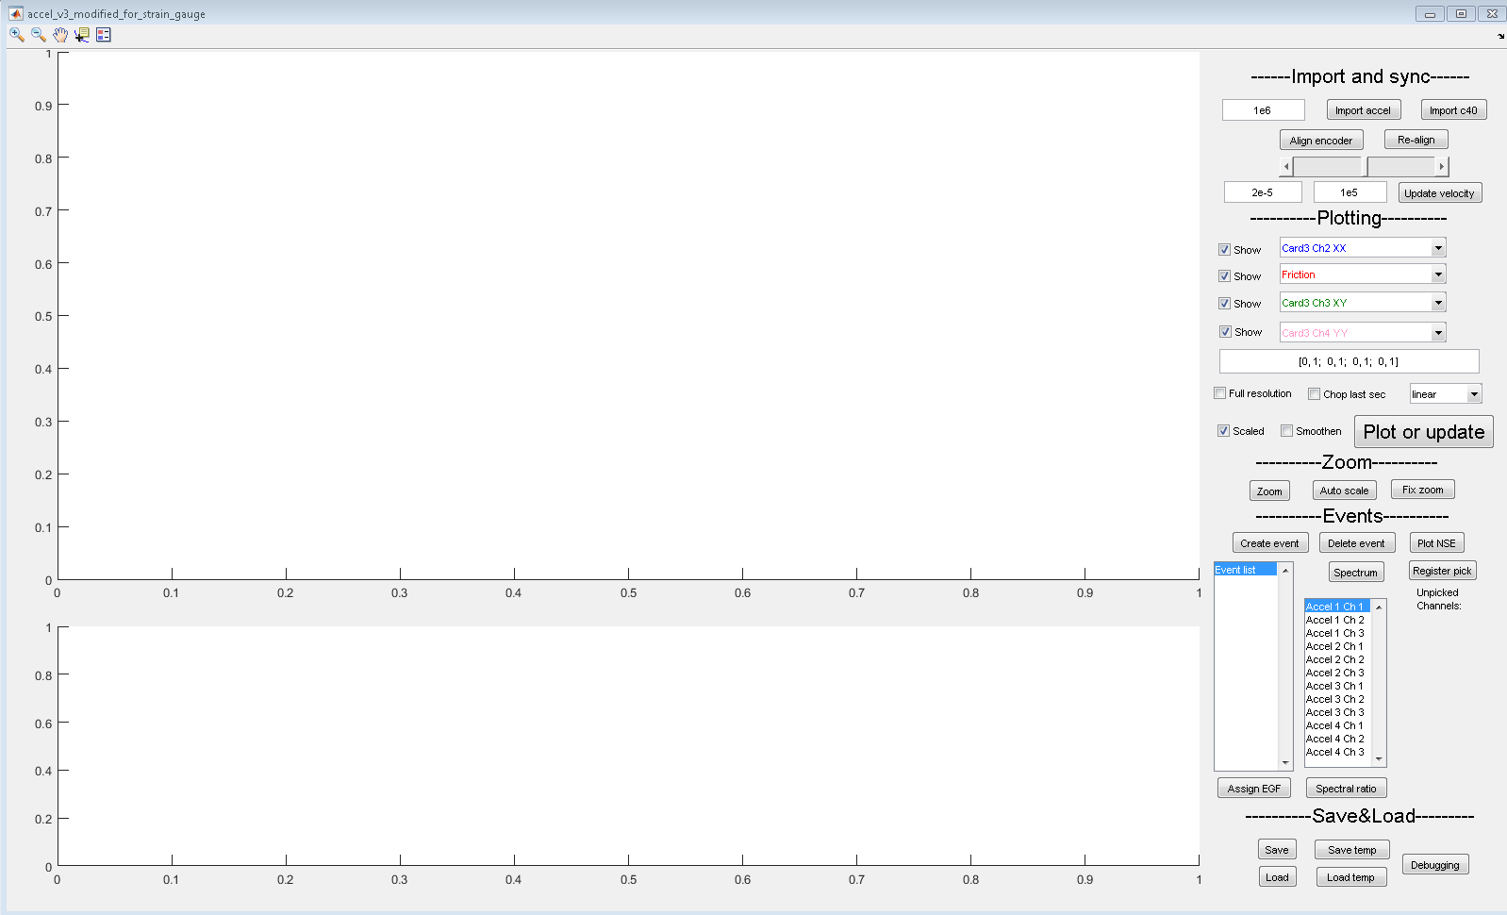

1. There are five sections on the panel: import and sync, plotting, zoom, events, and save&load. It is sufficient to only use plotting, zoom and save&load sections.
2. Click ‘Load’ button. Select a .mat file with a prefix ‘DB_’ (means database). Wait for a while and a window should pop up.

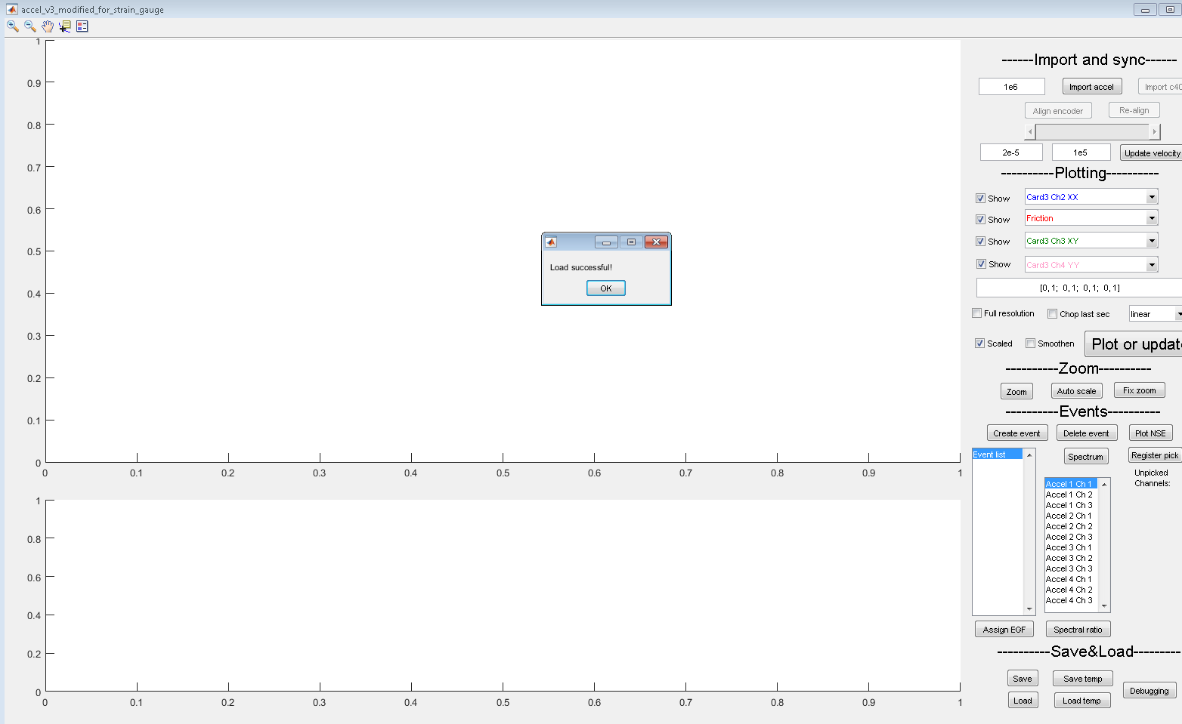

1. Click OK. Change dropdown menus in the plotting section as desired. Click Plot or update to plot the curves.
2. The ‘Show’ checkboxes show/hide corresponding curves. After checking/unchecking, click plot or update to update.
3. The text area below the dropdown menus allows offsets and slopes for each plot channel. It is structured as [offset1,slope1; offset2,slope2; offset3,slope3; offset4,slope4]. Each curve is then calculated by new = (old – offset)/slope. Figure below shows a desired set of values for experiment 6037. Make sure to turn off Scaled when using this offset and slope function.

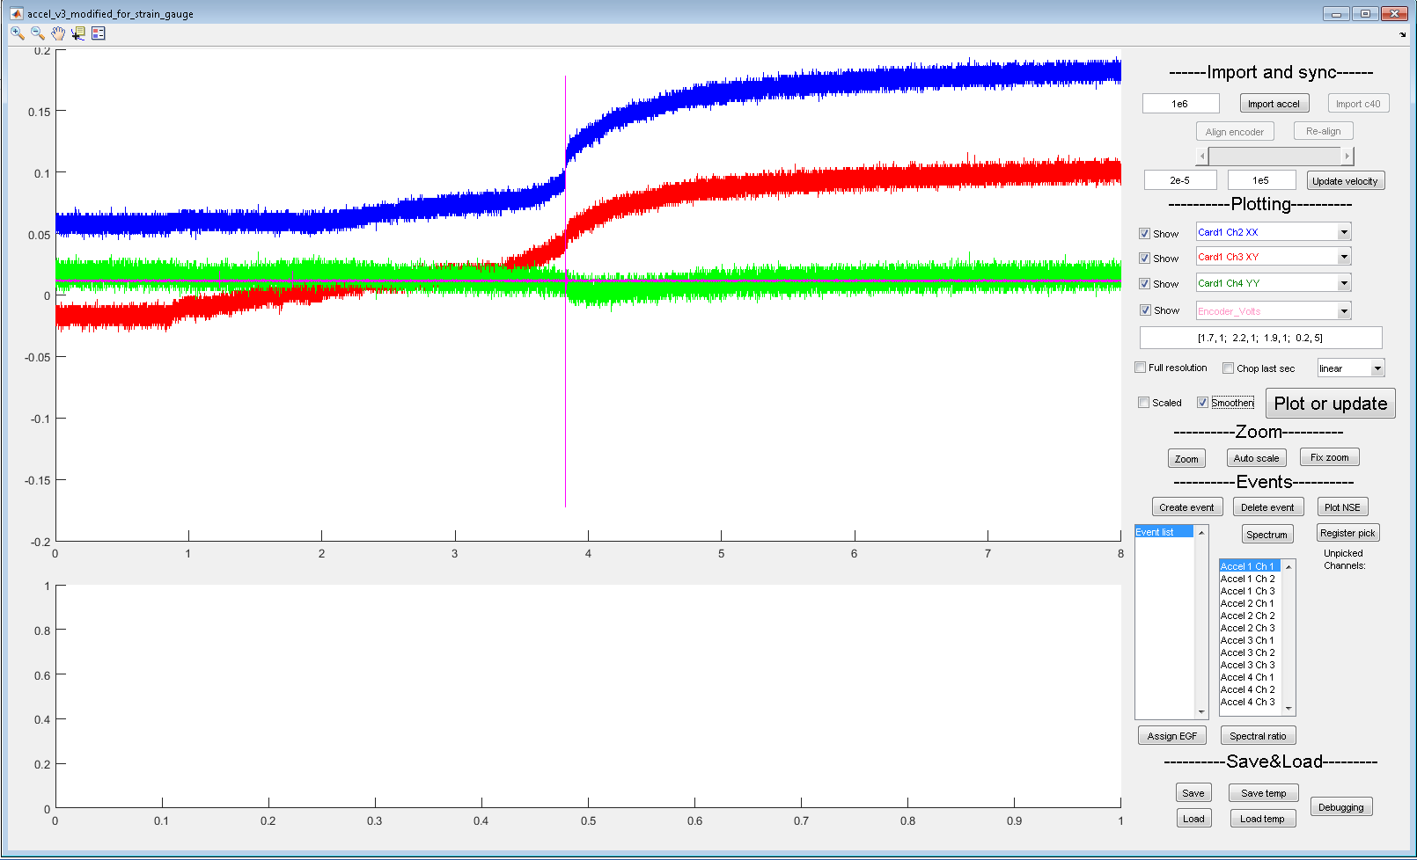

1. For granite experiments, Card 1 ~ 4 are actually all showing Card 1 data. Encoder_Volts channel shows channel 1 of card 1, i.e., the AE channel.
2. Auto scale button brings to full picture of the plot.
3. Checking/Unchecking Scaled, Full resolution, Chop last second automatically updates the plot. There is no need to click plot or update button.
4. Hover mouse pointer on Import accel button shows experiment number.